Design: UPDTCLOSE and Electronic EOD

Overview

Current processing
CBOEDirect currently calculates closing prices and generates the EOD summary for ONE_MAIN and CFE_MAIN sessions using the following two ar commands
- “updateSettlementPrices” in ProductMaintenanceService which calculates ONLY the closing prices and saves them in the “Product” table.
- “updateSummary” in MarketDataSummaryService which gathers recap information needed for sending end of day summaries and storing them in the “MarketDataSummary” and “Recap” tables.

New requirement
For W_MAIN session we are going to combine these steps into one step called “updateClosingPrices”. The admin request ‘updateClosingPrices <sessionName>’ will send a request to MarketDataSummaryService which runs in GlobalServer. MarketDataSummaryService queries TradingSessionService and MarketDataReportingService which in turn makes call to MarketDataService to get the closing price and recap data (closing quotes). The recap data and calculated closing info are updated in PRODUCT, MARKET_DATA_SUMMARY and RECAP tables.

The data from PRODUCT, MARKET_DATA_SUMMARY and RECAP tables in CBOEDirect (CD) will be replicated into Data Warehouse via CDB. Data Warehouse uses this data to display EOD summary data on CBOE website.

Scope
This document details out the design for calculating the closing prices, getting the closing recap data and updating into PRODUCT, MARKET_DATA_SUMMARY and RECAP tables.
It also details out the design for populating the tss_series table in DWH by getting data from MKT_DATA_SUM and MKT_DATA_RECAP tables in data warehouse
Data replication from PRODUCT, MARKET_DATA_SUMMARY and RECAP tables in CD into CDB and from CDB to Data warehouse is out of the scope for this document. This functionality will be implemented by CDB team.

Assumptions
    - cleanupServer is run at EOD after the updateClose is done and EOD summaries sent. This copies settlement/close price & suffix to yesterday’s close price & suffix respectively for the PRODUCT. So the two fields are different only for the duration of the EEOD and EOD summaries to OPRA. These would have same values throughout the day. When we fetch the closing price from the settlement_price we get yesterday’ closing price.
    - The closing price algorithm for each session is different
    - Last Sale would be available in MDRS.
- The last sale price is updated in the cache on every trade.
- MDRS would query the MDS for closing quotes, price, suffix information and overload only the Last Sale related information before returning the ClassRecapStructV5

Implementation

UpdateClose Flow - 1st diagram is the latest one.
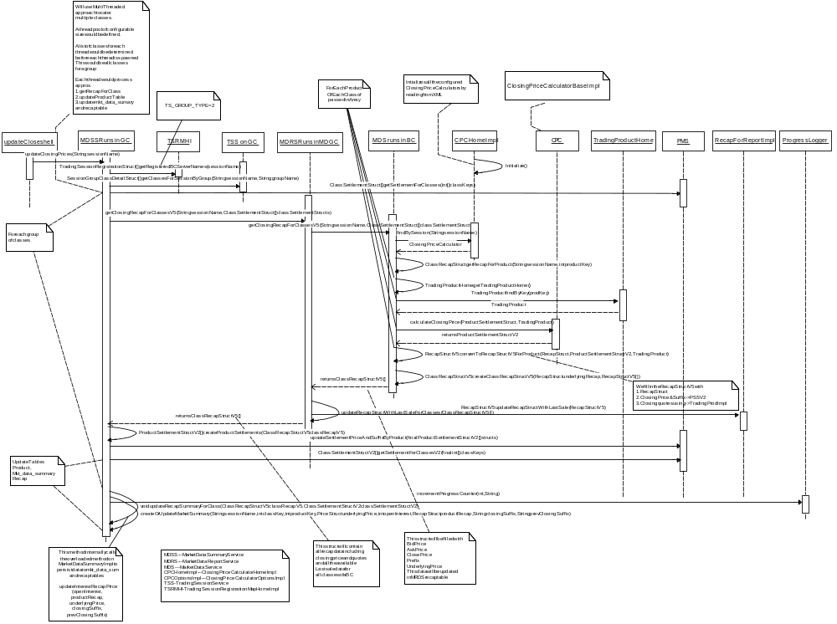

      - Operator executes updateClose shell script that takes single argument - sessionName
      - This triggers the admin request updateClosingPrices method of MDSS that runs in Global Server.
      - MDSS gets list of groups from TradingSessionRegistrationMapHome by method call getRegisteredBCServerNames(sessionName).
      - For each group name returned above get the list of classes for session by calling method getClassesForSessionByGroup of TradingSessionServices. Each call would return a SessionGroupClassDetailStruct[] for each group (each BC). From SessionGroupClassDetailStruct[] obtain array of class keys. Store this array in a hashmap with key as group name. Calculate total number of classes and store this count for progress logger. Create ProgressLogger object and pass this count to it.
      - Thread pool (JDK 1.5) of configurable size will be used. A list of classes for each thread is available in hashmap created above. Each thread will process list of classes for each BC to

- Fetch yesterday’ closing price from ProductMaintenanceService

- Pass ClassSettlementStruct[] to MDRS and fetch closing recap data from MDRS
- Match OpenInterest, Yesterday’s Closing Suffix for each product of each class.
- Update PRODUCT, RECAP and MKT_DATA_SUMMARY tables in CD GC database
      - For each set of classes, MDSS calls PMS’s new method getSettlementForClasses passing it the array of classKeys of one BC, to get yesterday’s closing price. This method returns the ClassSettlementStructs.
      - For each set of classes, MDSS calls getClosingRecapForClassesV5 on MDRS passing the sessionName and classSettlementStructs.
      - MDRS then calls the MDS’s method getClosingRecapForClassesV5 passing the sessionName and classSettlementStructs.
      - MDS then gets the Closing Price Calculator for passed in sessionName by calling findBySession(sessionName) of ClosingPriceCalculatorHomeImpl.
      - For each class of the passed in array of classes, MDS first gets the recap information by calling method getRecapForProduct(sessionName, productKey).
      - For each product of each class of the passed in array of classes
- MDS gets closing quotes from the TradingProduct. Passes the TradingProduct object to the calculator along with the ProductSettlement struct.
- The calculator returns the ProuctSettlementStructV2 with today’s closing price and suffix.
- The RecapStruct, ProuctSettlementStructV2, TradingProduct received above is used to create RecapstructV5 for the product with today’ closing price and suffix & closing quotes using private method convertToRecapStructV5ForProduct.
      - For each class create the ClassRecapStructV5 by calling the method createClassRecapStructV5 and pass it the ClassRecapStruct and RecapStructV5[]
      - The ClassRecapStructV5[] for all classes of the passed in classKeys is returned to the MDRS.
      - The MDRS uses the Recap cache to update the ClassRecapStructV5[]with Last sale data. The method updateRecapStructWithLastSaleForClasses is used for the purpose.The ClassRecapStructV5[] is returned to MDSS.
      - For each set of classes, MDSS calls PMS’s new method getSettlementForClassesV2 passing it the array of classKeys obtained from call to MDRS for one BC, to get yesterdays closing price, yesterdays closing suffix and OpenInterest. This method returns the ClassSettlementStructsV2.
      - MDSS uses the ClassRecapStructV5[], ClassSettlementstructV2[] (having yesterday’ closing price, suffix and OpenInterest) to update Product, mkt_data_summary and Recap tables. For each ClassRecapStructV5
- MDSS creates ProductSettlementStructV2[] from ClassRecapStructV5[]
- MDSS uses the PMS’ new method updateSettlementPriceAndSuffixByProduct(ProductSettlementStructV2 [] structs) to update the Product table with today’s settlement price and settlement suffix
- In method updateRecapSummaryForClass create a hashmap called settlementPrices with key as product key and value as productSettlementStructV2 array. Obtain class key, product key, open interest for each product.

- MDSS implements new method void updateRecapSummaryForClass(ClassRecapStructV5 classRecapV5, ClassSettlementStructV2 prevClassSettlementStructV2) which would sort the openinterest and yesterday;s closing suffix per product recap and further use the modified method createOrUpdateMarketSummary( String sessionName, int classKey, int productKey, PriceStruct underlyingPrice, int openInterest, RecapStruct productRecap, String closingSuffix, String prevClosingSuffix) within MDSS to update the mkt_data_summary and the recap table.

- IDL Changes
To achieve the creation and transmission functionality following idl’s must be modified

Product.idl
Location - domain/idl/product.idl
Add two structs as follows.
typedef String SettlementSuffix

struct ProductSettlementStructV2 {
Product::ProductSettlementStruct productSettlementStruct;
SettlementSuffix settlementSuffix;
long openInterest
};
typedef sequence <ProductSettlementStructV2> ProductSettlementStructV2Sequence;

struct ClassSettlementStructV2 {
ProductSettlementStructV2Sequence settlementsV2;
};
typedef sequence <ClassSettlementStructV2> ClassSettlementStructV2Sequence;

cmiMarketData.idl
Location - cmi/idl/cmiMarketData.idl
Add struct as follows –
Modify RecapStructV5 to add attribute RecapSuffix
typedef String RecapSuffix
struct RecapStructV5
{
RecapStruct recapStruct;
cmiUtil::DateTimeStruct lowPriceTime;
cmiUtil::DateTimeStruct highPriceTime;
cmiUtil::DateTimeStruct openingPriceTime;
RecapSuffix recapSuffix;

};
typedef sequence <RecapStructV5> RecapStructV5Sequence;

struct ClassRecapStructV5
{
RecapStructV5 underlyingRecap;
RecapStructV5Sequence productRecaps;
};
typedef sequence < ClassRecapStructV5> ClassRecapStructV5Sequence;

MarketDataReportService.idl
Location - server/idl/MarketDataReportService.idl
Add operation called

marketData::ClassRecapStructV5Sequence getClosingRecapForClassesV5(
in cmiSession::TradingSessionName sessionName,
in product::ClassSettlementStructSequence classSettlementStructs)
raises(
exceptions::SystemException,
exceptions::CommunicationException,
exceptions::DataValidationException,
exceptions::AuthorizationException
);

MarketDataService.idl
Location - server/idl/MarketDataService.idl
Interface name - MarketDataService – Add an operation called
marketData::ClassRecapStructV5Sequence getClosingRecapForClassesV5(
in cmiSession::TradingSessionName sessionName,
in product:: ClassSettlementStructSequence classSettlementStructs)
raises(
exceptions::SystemException,
exceptions::CommunicationException,
exceptions::DataValidationException,
exceptions::AuthorizationException
);

ProductMaintenceService.idl
Location – server/idl/ProductMaintenanceService.idl
void updateSettlementPriceAndSuffixByProduct( in product:: ProductSettlementStructV2Sequence settlements)
raises(
exceptions::SystemException,
exceptions::CommunicationException,
exceptions::DataValidationException,
exceptions::NotFoundException,
exceptions::TransactionFailedException,
exceptions::AuthorizationException
);
product::ClassSettlementStructV2Sequence getSettlementForClassesV2(
in cmiProduct::ClassKeySequence classKeys)
raises(
exceptions::SystemException,
exceptions::CommunicationException,
exceptions::DataValidationException,
exceptions::NotFoundException,
exceptions::AuthorizationException
);

3. Interfaces and Classes
Interfaces:
- com.cboe.interfaces.businessServices.ClosingPriceCalculator.java
  - ProductSettlementStructV2 calculateClosingPriceForProduct (ProductSettlementStruct, TradingProdcuct)
- com.cboe.interfaces.businessServices.ClosingPriceCalculatorHome.java
  - ClosingPriceCalculator create()
  - ClosingPriceCalculator findBySession(String sessionName)
- com.cboe.interfaces.domain.RecapForReport.java
  - RecapStructV5 updateRecapStructWithLastSale()

Classes:
- com.cboe.businessServices.marketDataSummaryService.MarketDataSummaryServiceHomeImpl.java
- Registers 2 ar commands.
- com.cboe.businessServices.marketDataSummaryService.MarketDataSummaryServiceImpl.java:
- void updateClosingPrices(String sessionName)
- Method registered for admin request.
- This method gets all groupNames for the Trade Server type by call getRegisteredBCServerNames on the TradingSessionRegistrationMapHome.
- This method gets all classes by group for given session name from TradingSessionService for each group name fetched above.
- ThreadPool of configurable size is defined. A list of classes for each thread would be determined before each thread is spawned. Each thread would process list of classes for each BC to gather yesterday’ closing price, recap data, calculate closing price and update the database tables.
ProductSettlementStructV2[] createProductSettlements(ClassRecapStructV5 classRecapV5)
- Method to create ProductSettlements from the ClassRcapStructV5 to update Product table with today’s settlementPrice and suffix
- void updateRecapSummaryForClass(ClassRecapStructV5 classRecapV5, ClassSettlementStructV2 prevClassSettlementStructV2)
  - Method to find openinterest, yesterday’s closing suffix and yesterday’s closing price for each productRecapV5 and pass it across to method createOrUpdateMarketSummary to update the mkt_data_summary and recap tables.
- void createOrUpdateMarketSummary( String sessionName, int classKey, int productKey, PriceStruct underlyingPrice, int openInterest, RecapStruct productRecap, String closingSuffix, String prevClosingSuffix)
  - Modify signature of existing method createOrUpdateMarketSummary to accept closingSufix and prevClosingSuffix. This would use the SummaryRecapImpl’ overloaded method updateForMarketDataSummary(RecapStruct, closingSuffix, prevClosingSuffix).
  - We will need to trace all calls to this method and modify the same to accept closingSuffix and prevClosingSuffix as null.
- com.cboe.businessServices.marketDataReportService. MarketDataReportServiceImpl.java
- ClassRecapStructV5[] getClosingRecapForClassesV5(String sessionName, ClassSettlementStruct[] classSettlementStructs).
- This is called from MDSS.
- It then calls getClosingRecapForClassesV5 of MarketDataService to get the ClassRecapStructV5
- Calls private method updateRecapStructWithLastSaleForClasses
- updateRecapStructWithLastSaleForClasses(ClassRecapStructV5[])
- To update ClassRecapStructV5[] fetched above with LastSale information referring the cache.
- com.cboe.businessServices.marketDataService.MarketDataServiceImpl.java
- ClassRecapStructV5[] getClosingRecapForClassesV5(String sessionName, ClassSettlementStruct[] classSettlementStructs)
- Creates ClassRecapStructV5[] with closing quotes, calculated closing price and suffix for each class for requested classes.
- First gets the Closing Price Calculator findBySession passing the sessionName.
- Creates ClassRecapStruct for each class of the requested classes, by calling getRecapForClass(sessionName, classKey)
- Calls method TradingProduct findByKey(prodKey) on TradingProcductHome to get TradingProduct for passed in product.
- Calls calculateClosingPrice passing the ProductSettlementStruct, TradingProdcuct to the ClosingPriceCalculator that would return the ProductSettlementStructV2 for each product
- The RecapStructV5[] for all products is created overriding the values for closing price and closing quotes from ProductSettlementStructV2 and TradingProduct above.
- Create ClassRecapStructV5 for each class from the RecapStructV5[] and ClassRecap fetched in first call
- RecapStructV5 convertToRecapStructV5ForProduct(RecapStruct, ProductSettlementStructV2, TradingProduct)
- Creates RecapStructV5 from passed in RecapStruct, ProductSettlementStructV2 and TradingProduct
- ClassRecapStructV5 createClassRecapStructV5(RecapStruct underlyingRecap, RecapStructV5[])
- Create ClassRecapStructV5 from the passed in array of RecapstructV5 and the underlyingRecap.
- com.cboe.internalBusinessServices.productService.ProductMaintenanceService.java
- void updateSettlementPriceAndSuffixByProduct( final ProductSettlementStructV2 [] structs )
- Create new method updateSettlementAndSuffixByPoduct that accepts ProductSettlementV2 []
- ClassSettlementStructV2[] getSettlementForClassesV2(int[] classKeys)
- Create new method getSettlementForClassesV2 to return the yesterday’s closing price, yesterday’ closing suffix and open interest for the passed in array of classKeys.
- com.cboe.domain.product.ProductImpl.java
- Add following fields, getter, and setters corresponding to newly added columns in PRODUCT table.
  - settlement_price_suffix
  - yesterdays_close_price
  - yesterdays_close_price_suffix
- com.cboe.domain.marketDataSummary.SummaryRecapImpl.java
- Add following fields, getter, and setters corresponding to newly added columns in RECAP table.
  - close_price_suffix
  - yesterdays_close_price
  - yesterdays_close_price_suffix
- void updateForMarketDataSummary(RecapStruct recap, closingSuffix, prevClosingSuffix)
  - Overload existing method updateForMarketDataSummary(RecapStruct recap) to accept RecapStruct, closingSuffix and prevClosingSuffix
  - This would additionally update the close_price_suffix, yesterday’s close price and yesterday’s close price suffix column of Recap table
- com.cboe.domain.marketDataSummary.MarketDataSummaryImpl.java
- updateInterestRecapPrice(openInterest, productRecap, underlyingPrice, closingSuffix, prevClosingSuffix)
- Overload method updateInterestRecapPrice( openInterest, productRecap, underlyingPrice) to accept parameters closingSuffix and prevClosingSuffix
- com.cboe.interfaces.businessServices. ClosingPriceCalculatorHomeImpl.java
- This class is used to create ClosingPriceCalculator.
- ClosingPriceCalculator findBySession(String sessionName)
Gets the Closing Price Calculator, for the sessionName= W_MAIN returns the object of ClosingPriceCalculatorOptionsImpl.
- public synchronized void initialize()Initialize method reads session names and implementation classes from XML and puts them in PropertyInfo.
- public synchronized void goMaster(boolean failover) - Empty implementation
- public synchronized void goSlave() - Empty Implementation
- com.cboe.interfaces.businessServices. ClosingPriceCalculatorBaseImpl.java:
This is a base class for classes implementing settlement price calculation algorithm.
- public ProductSettlementStructV2 calculateClosingPrice(ProductSettlementStruct, TradingProduct)- Default implementation.
- Public PriceStruct determineSettlementPrice(Price tradePrice, Price bid, Price ask) – Default implementation.
- Public String determineSettlementSuffix(Price tradePrice, Price bid, Price ask) – Default implementation.
- Public Boolean validClosingQuote(Price bid, Price ask)- Determines whether quotes are valid.
- Public Boolean isZeroPrice(Price price)- Determines whether price is a ZERO_PRICE.

- com.cboe.interfaces.businessServices. ClosingPriceCalculatorOptionsImpl.java:
- calculateClosingPrice (ProductSettlementStruct, TradingProduct)
- This method implements the algorithm.
This is a session dependent algorithm, will be separate for each session. Mentioned below is the algorithm and flowchart for W_MAIN session.
- Uses private methods
Price determineSettlementPrice(Price tradePrice, Price bid, Price ask)- Method called without any argument for new series.
Price determineSettlementSuffix(Price tradePrice, Price bid, Price ask) – Overloaded method called with the LSP if the product is traded today else with previous closing price.
Need to determine if validClosingQuotes() should be used as in the existing flow? How will it affect the algorithm? The questions section is updated with the same.
- com.cboe.util.ProgressLogger.java:
- public synchronized int incrementProgressCounter(long incrementBy, String message) – Overloaded method which calculates percentage of update completed.

- com.cboe.domain.marketDataReportService.RecapForReportImpl.java:
- public RecapStructV5 updateRecapStructWithLastSale(RecapStructV5) – Updates recapStructV5 with last sale related data by fetching it from MDRS cache.

Flowchart:
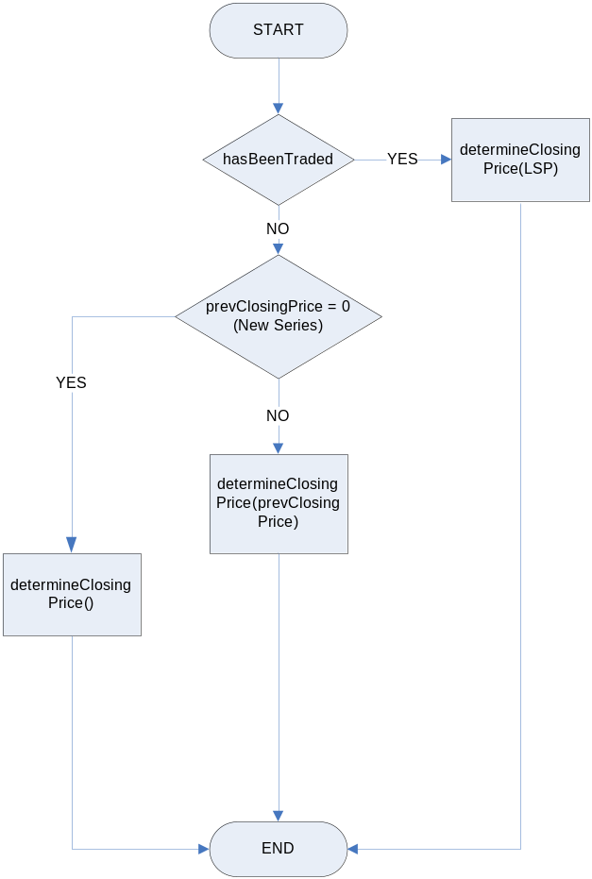

Algorithm:
Refer LSP as Last Sale Price and PrevSettlementPrice as Yesterday’s closing price
Case1– If series had a LSP today. Use LSP for the below calculation Or else use Previous Closing Price
Compare bid and ask with LSP. If it falls between the two, new settlement price is equal to LSP and closing suffix is blank
If bid is greater than LSP, new settlement price is same as bid and closing suffix =’B’
If ask is greater than LSP, new settlement price is same as ask and closing suffix =’A’
Case2– If series did not have LSP today.
Compare bid and ask with PrevSettlementPrice. If it falls between the two, new settlement price is equal to PrevSettlementPrice and closing suffix is blank
If bid is greater than PrevSettlementPrice, new settlement price is same as bid and closing suffix =’B’
If ask is greater than PrevSettlementPrice, new settlement price is same as ask and closing suffix =’A’
Case 3 – A new series (It is a new series if PrevSettlementPrice = 0)
If Ask is non-zero then new settlement price is same as ask and closing suffix =’A’
Else don’t update closing price

Logging
1. Informative messages will be logged at the beginning and end of each important method.
2. Logging for updateClosingPrices would be done per percent completion basis.

Exception Handling
1. All the exceptions will be propagated to the top level i.e. the method that is called from the ar command. This method will then log the exceptions (Log.exception) and return appropriate status from the method.

Scripts(2)
- updateClose <sessionName>- This script triggers the admin request which calculates the closing prices and as well as closing recap data and stores into PRODUCT, RECAP and MKT_DATA_SUMMARY tables.
- ReleaseUpdateCloseLock – This script will release lock on update close.
- cleanupServer- The script cleanupServer needs to be modified to copy settlement_price and settlement_price_suffix into yesterdays_close_price and yesterdays_close_price_suffix. These are the fields from PRODUCT. This also cleans up the MarketDataSummary table for series that are either in-active or no longer exists. The exact changes are not yet identified/finalized.
- SchedLoadEEOD_B.sh - This shell script triggers the sql in DWH to consolidate data from mkt_data_sum and mkt_data_recap and Series_Arch and Class_Arch and update the TSS_SERIES table.

Database(.5)
Changes in GC database
- PRODUCT table changes.
  - settlement_price_suffix
  - yesterdays_close_price
  - yesterdays_close_price_suffix
- MARKET_DATA_SUMMARY table changes.
None.
- RECAP table changes.
  - close_price_suffix
  - yesterdays_close_price
  - yesterdays_close_price_suffix

The following explains the EEOD flow and changes required:
- CDB does near real-time replication of CBOEDirect data.
- CDB also pushes the same to the DWH once at end of day.
- CDB needs to make necessary changes to accommodate the SBT changes into the above mentioned process.
- DWH has procedures to consolidate data from mkt_data_sum and mkt_data_recap and SerieS_Arch and Class_Arch and update the TSS_SERIES table.
- Market statistics web report is generated from TSS_SERIES table.
- Need to modify the process (UNIX and SQL) and unit test the same to accommodate the database changes on SBT.
Please refer the diagram below:
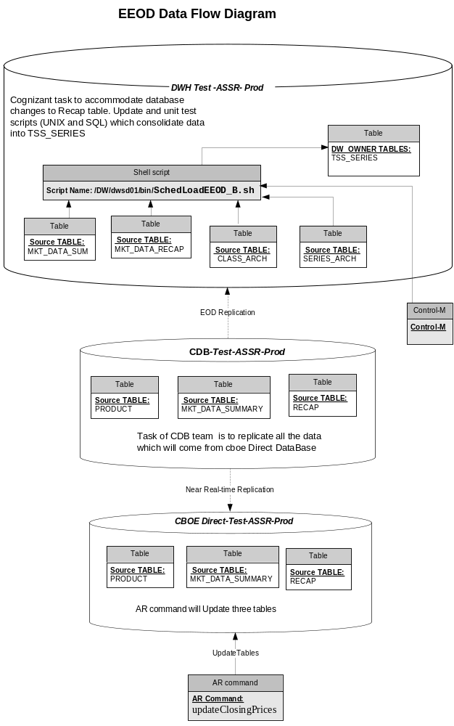

SetContext(.125)
None

XML/DTD(.5)
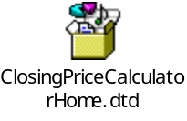
Snippet of TradeServer.xml

<BOHome name="ClosingPriceCalculatorHome">
<BOHomeProperties>
<homeImpl>
com.cboe.businessServices.marketDataService.ClosingPriceCalculatorHomeImpl
</homeImpl>
<managedResourceName>
ClosingPriceCalculatorHomeImpl
</managedResourceName>
<poaName>TradeServer&lt;prefixPoaPair&gt;POA</poaName>
<objectId>ClosingPriceCalculatorHome&lt;prefix&gt;TradeServer</objectId>
</BOHomeProperties>
</BOHome>

Homes/Services(2)
- MarketDataSummaryService
- MarketDataReportingService
- MarketDataService
- Product
- Recap (Persistent impl – SummaryRecap)
- ProductMaintenance
- ClosingPriceCalculator
- TradingSessionRegistrationMapHome

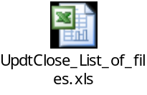

ImplPlan(.5)
None

PerformanceTestingProcedure(1)
Performance needs to be checked how long it takes to update summaries for a full product set of 200,000 series.

TestingProcedure(1)
None

OperatorProcedure(.5)
The Update close would be triggered from the updateClose script which would be a wrapper over the admin request updateClose.

Fallback/Failover
None

GUI Design

Queries
- How do we check the updateClose is triggered for Composite OR Equity and Index? These are run at different time of day
Ans: This is out of scope. The update close would operate at session level.
- How to check End of session and End of Sale? This would be essential to check if updateClose is triggered during trading hours.
Ans: Use the showProductStatesBySession for the purpose.

A sample output of the command is:

Show product state for session list {W_MAIN}:
------------------------------------------------------------------
Product states for session W_MAIN:
state CLOSED count = 24507
state OPENING_ROTATION count = 114
state OPEN count = 65
state NO_SESSION count = 156598
state ON_HOLD count = 9

How do we use this output to conclude that all products are closed?

Ans: Everthing other than CLOSED should be considered for popping a question asking Y/N

- The details of the cleanupServer are required as what all tables need to be truncated/deleted for the purpose and the criterion for the same. Are there any existing scripts (SQL) which do this?
  - The high level design mentions: At end of day cleanupServer should cleanup the MarketDataSummary and Recap tables on the GC for those series that are either in-active or no longer exist (This will allow us to keep MarketDataSummary for an extra day for debugging purposes). But then the code should allow for updates/additions since the data from previous day may already exist. NOTE – we don’t need to keep track of summaries for Strategy products.
Today the cleanupServer truncates the recap and mkt_data_summary table. Nothing is done to the Product table. Do we need to change the truncate to delete depending on the series being active?
This in addition to sql to copy yesterday’s close price and yesterdays closing suffix from today’s values for Product table.
- In EEOD how is the CDB replication triggered?
- As in existing flow do we need something as validClosingQuotes() to verify valid quotes? Will the implementation logic be the same? How will it affect the algorithm?
- Need to identify the source for the bid_time, ask_time, bid_dir and otc_ind in the Recap table
Ans: Since we get the Recap from MDS getRecapForClass we would get these values in the returned ClassRecapStruct
- Current design has the Settlement and Recap data are updated in separate transactions. Should we put this in same transactions so that it would be atomic
- Need to check what method needs to be used to get group names for session? This is required to give call to the TSS getClassesForSessionByGroup(String sessionName, String groupName)
Ans: We get the group names from the ConfigurationGroupHome query findByType. This returns an array of the groupNames. For each groupName received we would fetch the class information for session by call getClassesForSessionByGroup to TradingSessionService.

- Need to determine how we get reference to a particular MDS by passing a classKey before passing request for the complete set of classes of a BC.
Ans: We configure the MarketDataServiceHome in MDRS with MarketDataServiceNonExportingRoutingProxyHomeImpl and MarketDataServiceRoutingProxyInterceptor
- Why the TRADE_SERVER_GROUP_TYPE = 2?
- If MDRS caches the openInterest data (for HVOL from the same source Product Table) why do we query the PMS for openInterest data? Are we missing anything here? Wil the values be different? Similar doubt for Yesterday’ settlement Price?

Suggestions
  - In MDSS we fetch yesterday’s closing price and settlementSuffix from PMS. We pass the same struct to the MDRS for closingPrice calculation. Can we modify the RecapStructV5 to accommodate the yesterday’s closing price suffix? So the MDRS/MDS can set this in the RecapstructV5 and we get the same information in returned ClassRecapStructV5.
    - Not doing so we have the overhead of comparing the ClassSettlementStructV2 we have above, ClassRecapstructV5 returned by MDRS and ClassOpenInterestStruct which we get in MDSS after reading OpenInterest from Product table.
Response
- We get the OpenInterest, and yesterdays’ closing price and suffix in a single call to PMS getSettlementForClassesV2. The ProductSettlementStructV2 is modified to accommodate OpenInterest

Suggestion to response a :
- If we could pass the ClassSettlementStructV2 to MDRS we could save the overhead of sorting and matching the open interest, yesterday’ closing suffix to each product recap in function updateRecapSummaryForClass. We can modify the recapStructV5 to accommodate one more suffix (yesterday’s closing suffix) and return all the data in the returned ClassRecapStructV5.
Response
b. Not Acceptable

Suggestion after response b:
- We do not update the OI, yesterday’s closing suffix to the MKT_DATA_SUMMARY & RECAP table in the current flow. Instead call a separate SQL job which would read the same from PRODUCT table and update the MKT_DATA_SUMMARY & RECAP.
  - We would create an hashmapfrom the array of classSettlementStructV2. We would need to traverse this array only once.
Response
Get the array and convert into Hash map in method level.

